R Programming Assignment 2 Answer Scripts – Week 3: Caching the Inverse of a Matrix

Cachematrix.R
Matrix inversion is usually a costly computation and there may be some benefit to caching the inverse of a matrix rather than computing it repeatedly. Do note that there are alternatives to matrix inversion. Below are two functions that are used to create a special object that stores a matrix vector and caches the inverse of its matrix.

The first function, makeCacheMatrix creates a special "matrix" object that can cache its inverse.
It is really a list containing a function to
- set the value of the matrix
- get the value of the matrix
- set the value of the inverse matrix
- get the value of the inverse matrix
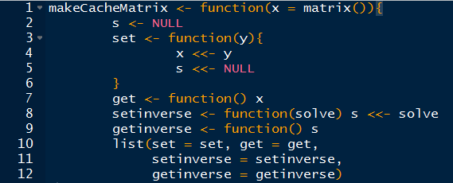

The following function cacheSolve computes the inverse of the special "matrix" returned by the makeCacheMatrix function above. However, it first checks to see if the inverse has already been calculated and the matrix has not changed. If so , the cacheSolve should retrieve the inverse from the cache and skips the computation. Othwise it computes the inverse of the matrix and sets the inverse matrix in the cache via the setinverse function.
